CHS Bathy Application Knowledge Transfer (KT) Document

1. General Information
Project Name | CHS Bathy Application
Department/Team | Frontend Development
Prepared By | Lithil Kumar Sunchrikota
Date
Receiver’s Name | Ameer Khan, Kishore Kumar, Habib

2. Overview
- Project Overview: The CHS Bathy Application is a specialized tool designed to compare depth ranges between S-57 and S-101 mismatch datasets at specific geolocations. Users can apply custom range and threshold values to analyse and compare bathymetric data across selected mismatch layer datasets.
- Purpose of this Document: To provide a comprehensive knowledge transfer for frontend development, UI implementation, Comparing the dataset functionality, deployment, and maintenance of the CHS Bathy Application.
- Key Responsibilities:
  - UI development using React.js, Open layers
  - Managing environment configurations using .env files
  - Deployment using Docker pipeline
  - GitLab version control and collaboration
- Architecture Overview:
The CHS Bathy Application is a web-based tool built with React.js and Vite.js for fast and responsive performance. It uses React Bootstrap and Bootstrap 5 to create a clean and mobile-friendly user interface. The app manages data using Context API. For mapping and comparing depth data, it uses Open Layers and connects to GeoServer. The app is packaged and deployed using Docker, with a CI/CD pipeline to automate building and updates. Environment settings are managed through .env files for both development and production. The code is version-controlled in GitLab, where team members collaborate and manage updates.

3. Technology Stack:
The CHS Bathy utilizes a modern, Stack technology ecosystem optimized for building interactive GIS web applications. Below is a breakdown of the technologies used and their respective roles within the project
Category | Technologies
Frontend | React.js ,Vite.js, React Bootstrap, Bootstrap 5 framework, Responsive Web
State Management | Context API
Mapping & Spatial Data | Open Layers, Geoserver
Deployment | Docker, CI/CD pipeline
Environment Management | .env files (Dev & Production)
Version Control | GitLab

4. Code Repositories & Access:
- GitLab Repository: http://gitlab.iictechnologies.local/iicic/chsbathy
- Credentials of GitLab Access: LDAP Credentials of your system
      - Username: Employee Id
      - Password: Your System Password
Note: If you want the permissions for accessing the Gitlab you may need to contact with system / IT Admin.
- Branching Strategy:
    - Single Branch Workflow:
      - All development is done in a single maintained branch.
      - Changes are directly committed and pushed to this branch.
      - The branch is regularly updated and published to ensure stability
    - Jenkins Pipeline & Deployment:
      - Once code is merged into release, Jenkins triggers the pipeline.
      - The pipeline builds the application using Docker and deploys it to production.

- Environments & Credentials:
  - Development: Configured via .env files
  - Production: Configured via .env files (Stored securely)
- Deployment Process:
  - Build frontend using Vite.js
  - Push changes to GitLab
  - Docker containerization and CI/CD pipeline execution
  - Deployment to production environment
- Docker Environments:
  - Two separate Docker files are maintained:
    - Docker Dev: This file is used for running the pipeline in the development environment. It triggers the .env development file and ensures a consistent environment for testing and local execution.
    - Docker Prod: This file is used for the production environment. It triggers the Docker production file, takes the .env production configuration, and builds the application for deployment.
    - Both Docker files are structured to support different environment variables and configurations as per .env files, enabling seamless transitions between development and production environments.
- Application URLs:
CHS Bathy Application
Development |  | Production
Application URL | NO | http://14.142.106.207:8000  https://s158.iictechnologies.com/
Geo Server URL | NO | http://14.142.106.212:8080/geoserver  https://ai.iictechnologies.com/geoserver

- This is the user interface of the CHS Bathy Application.
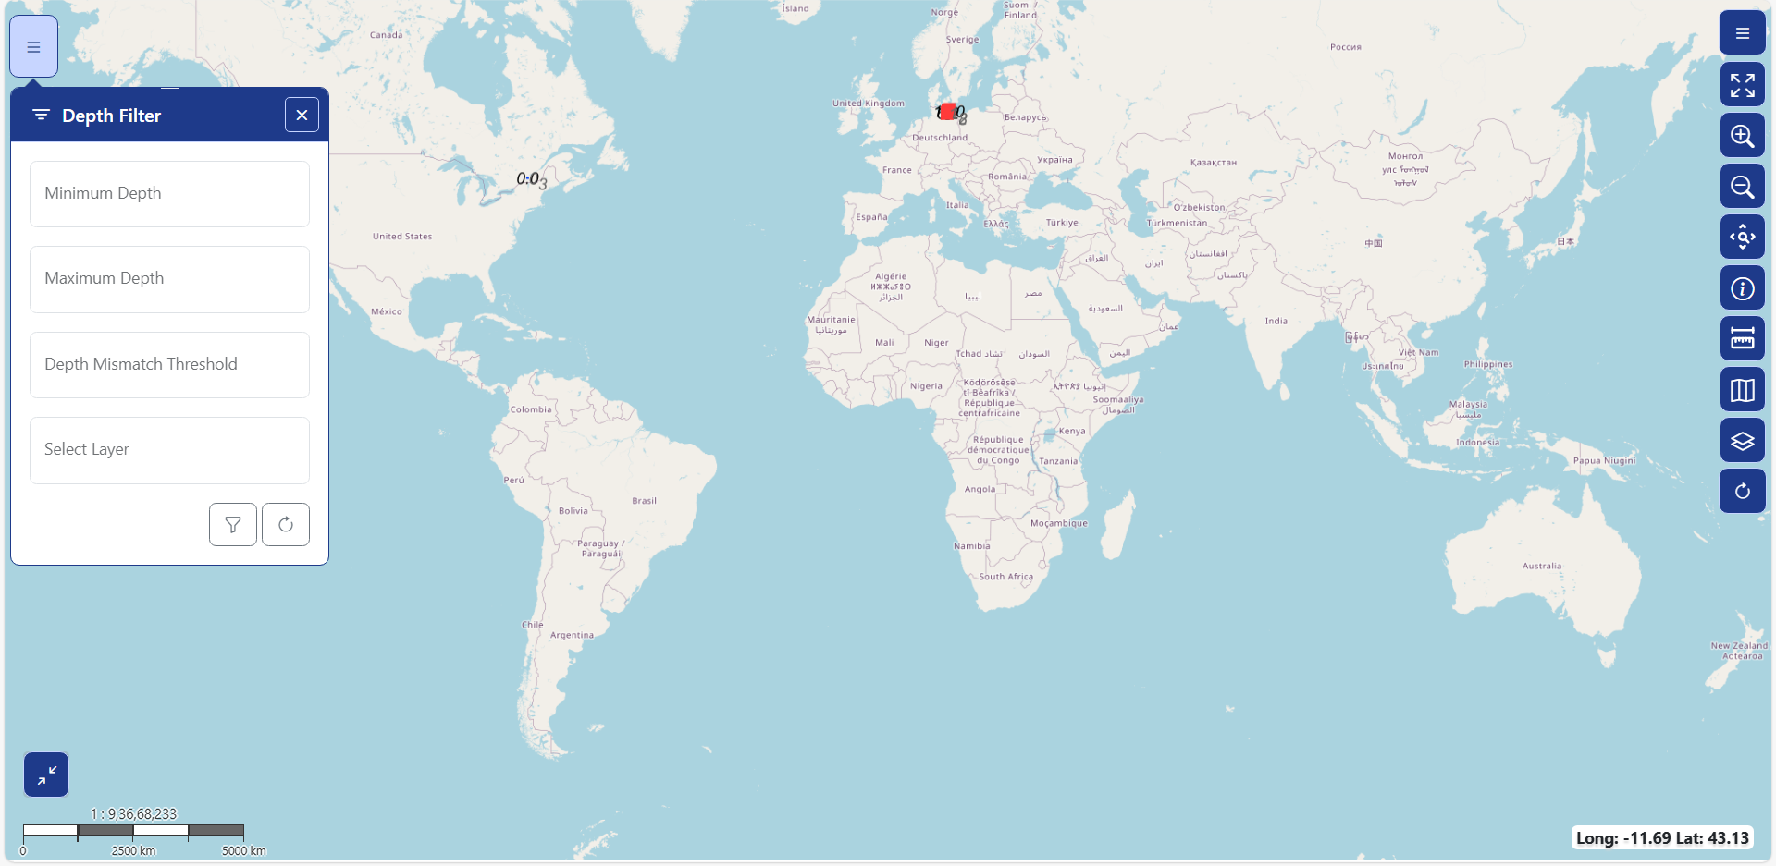
- The below code is used to compare bathymetric data across selected mismatch layer datasets.
if (olMap) {
const layersList = olMap.getLayers().getArray();
for (const lyr of layersList) {
if (lyr instanceof ImageLayer && lyr.getSource() instanceof ImageWMS) {
const params = lyr.getSource().getParams();
const layerTitle = lyr.get('title');

if (selectedLayerItem === layerTitle) {
const depthConditions = {
'S57 VALSOU mismatch': 'S102Depth',
'S-57 Other areas with DRVAL1 mismatch': 'S57Depth',
'S-57 Sounding mismatch': 'S57Depth',
'S-57 Depth areas mismatch': 'S57Depth',
'S-101 VALSOU mismatch': 'S101Depth',
'S-101 Sounding mismatch': 'S101Depth',
'S-101 Depth areas mismatch': 'S101Depth',
};

if (lyr.getVisible()) {
const depthField = depthConditions[layerTitle];
if (depthField) {
params.cql_filter = `${depthField} > ${minValue} AND ${depthField} < ${maxValue} AND DepthMismatch > ${thresholdValue}`;
}
}
lyr.getSource().updateParams(params);
}
}

